Generative Adversarial Networks
1. **Generative**: This term refers to the primary function of one part of the network, which is to generate new data. In the context of GANs, the generator network learns to generate synthetic data that is similar to the real data it has been trained on. For example, if the GAN is trained on a dataset of images of cats, the generator's task is to create new images of cats that look like they could belong to the same dataset.
2. **Adversarial**: This aspect refers to the adversarial relationship between two neural networks within the GAN framework. The generator and discriminator networks are in a kind of competition or adversarial game. The generator aims to create realistic data to fool the discriminator, while the discriminator aims to correctly distinguish between real data and data generated by the generator. These adversarial dynamic drives both networks to improve over time.
3. **Networks**: GANs consist of two neural networks: the generator and the discriminator. These networks are typically implemented using deep learning architectures, such as convolutional neural networks (CNNs) for tasks involving images. The generator network takes random noise as input and generates data samples, while the discriminator network takes data samples (either real or generated) as input and predicts whether they are real or fake.
A Generative Adversarial Network (GAN) is a framework that comprises two neural networks (generator and discriminator) engaged in an adversarial training process. The generator aims to generate realistic data, while the discriminator aims to distinguish between real and fake data, resulting in the generation of high-quality synthetic data.

Generative Adversarial Networks (GANs) have garnered significant attention in the field of Artificial Intelligence, not just for their innovative methods in generating and enhancing data, but also for their fundamental role in applications such as creating photorealistic images, transforming styles in pictures, and generating realistic human faces among others. First unveiled by Ian Goodfellow and his team in a 2014 NeurIPS paper, GANs stand out as machine learning systems adept at replicating specific data distributions. At their core, they consist of two interlinked neural networks: the generator, responsible for creating data, and the discriminator, whose task is to differentiate between genuine and simulated data. This interplay results in a unique training process, with GANs operating in an “adversarial” manner, formulated as a supervised learning challenge. Here, the generator aspires to craft data so genuine that the discriminator is deceived approximately 50% of the time.
One notable advancement within GANs is the emergence of Deep Convolutional GANs (DC-GANs), which utilize convolutional layers and have proven especially effective in generating high-quality, realistic images for a myriad of applications. These networks have been very important in various achievements in image and video generation. Renowned applications include the transformation of image aesthetics via CycleGAN and the synthesis of hyper-realistic human faces using StyleGAN, as exemplified on the “This Person Does Not Exist” platform.

Architecture
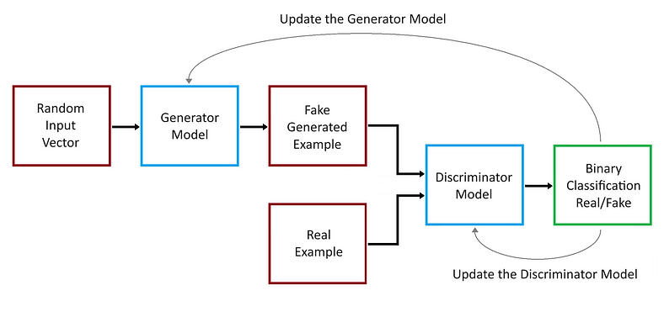
A Generative Adversarial Network (GAN) consists of two neural networks, namely the Generator and the Discriminator, which are trained simultaneously through adversarial training.
- Generator: This network takes random noise as input and produces data (like images). Its goal is to generate data that’s as close as possible to real data.
- Discriminator: This network takes real data and the data generated by the Generator as input and attempts to distinguish between the two. It outputs the probability that the given data is real.
During training, the Generator tries to produce data that the Discriminator can’t distinguish from real data, while the Discriminator tries to get better at differentiating real data from fake data. The two networks are in essence competing in a game: the Generator aims to produce convincing fake data, and the Discriminator aims to tell real from fake. This adversarial process leads to the Generator creating increasingly better data over time.

GAN Model Training
During training, GAN takes in two inputs, random noise data and an input data that is not labelled. Using these two inputs, it generates data that resembles the input data. Since all the inputs to the GAN are unlabelled, GAN is a type of unsupervised machine learning.
Internally GAN has two neural networks that compete with each other. The goal of the generator network is to deceive the discriminator network and the goal of the discriminator network is to correctly identify if the input is real or fake.

Generator
The generator’s primary role is to generate data. Initially, this data is likely to be random noise because the generator starts without much knowledge about the true data distribution. Over time, as the GAN is trained, the generator learns to produce data that approximates the real data distribution.
Input: The generator takes in a random noise vector, usually sampled from a normal or uniform distribution. This vector serves as a seed or starting point for data generation.
Architecture: While the architecture can vary, generators in many popular GANs (like DCGAN) are built using transposed convolutional layers (often called “deconvolutional” layers, though that’s a misnomer), which help in upsampling the noise vector to produce an image. The generator usually consists in the sequence of the following components.
- Input Layer: The generator starts with an input layer that takes in a random noise vector, usually sampled from a normal or uniform distribution.
- Fully Connected Layers: Early in the network, fully connected layers may be used to transform the input noise vector into a suitable shape for further processing.
- Batch Normalization: This technique is often used between layers to stabilize learning by normalizing the output of a previous layer. It helps in addressing issues like mode collapse and aids in faster convergence.
- Activation Functions: ReLU (Rectified Linear Unit) or Leaky ReLU are common choices for activation functions in the generator. These functions introduce non-linearity to the model, enabling it to generate complex data.
- Transposed Convolutional Layers: Also known as deconvolutional layers (though technically a misnomer), these layers are fundamental in the generator. They upsample the input from the previous layer to a higher spatial dimension, effectively doing the opposite of what convolutional layers do in a CNN.
- Reshaping Layers: These layers are used to reshape the data into the desired output format, especially when generating images.
- Output Layer: The final layer usually employs a tanh or sigmoid activation function, depending on the nature of the data being generated. For image generation, a tanh function is often used to output pixel values in a normalized range.
- Training: During training, the generator continuously learns to produce data that the discriminator can’t distinguish from real data. The generator updates its weights based on feedback from the discriminator, refining its ability to create convincing fake data.
Output: The generator produces data as its output. In the case of a GAN designed for image generation, the output would be an image. The data is then passed to the discriminator to be classified as real or fake.
Training: During training, the generator tries to deceive the discriminator by producing data that the discriminator can’t distinguish from real data.
The generator updates its weights based on feedback from the discriminator. If the discriminator correctly identifies the generated data as fake, the generator adjusts its weights to produce more convincing data during the next iteration.
The process is a kind of “game” where the generator constantly tries to improve, aiming to eventually produce data that’s nearly indistinguishable from real data.
Challenges:
- Mode Collapse: This is a situation where the generator produces a limited variety of outputs, even if trained on diverse data. It’s like the generator figuring out one particular “type” of fake data that the discriminator struggles with and then producing only that kind of data. It can be mitigated by introducing regularization techniques, and diversity-promoting loss functions, or using different training methodologies like minibatch discrimination.
- Training Instability: GANs, in general, are notorious for being difficult to train, with the generator’s training being particularly challenging. This is because the optimization landscape involves two models (generator and discriminator) that are being trained simultaneously in a dynamic setting. This problem can be reduced by adopting employ techniques such as Gradient Penalty, using learning rate schedulers, or adopting more specific GAN architectures that are more stable for the given problem.

Discriminator
The discriminator’s role is to distinguish between real and fake data. If you’re thinking about GANs in the context of images (which is a common application), the discriminator tries to tell apart real images from the fake images generated by the generator.
Input: Receives data samples, which can be either real data or generated data.
Output: Provides a scalar value between 0 and 1, representing the probability that the input sample is real. A value close to 1 suggests the sample is likely real, while a value close to 0 suggests it’s likely fake.
The actual architecture (like the number of layers, type of layers, etc.) can vary widely based on the specific problem and dataset. For image data, discriminators often use convolutional neural networks (CNNs).
Architecture: The architecture of the discriminator often mirrors that of traditional convolutional neural networks (CNNs), but with some adjustments. It usually consists in the sequence of the following components.
- Convolutional Layers: These layers are fundamental in processing image data. They help in extracting features from the input images. The number of convolutional layers can vary depending on the complexity of the data.
- Batch Normalization: This is sometimes used between layers to stabilize learning by normalizing the input to a layer.
- Activation Functions: Leaky ReLU is a common choice for activation functions in the discriminator. It allows a small gradient when the unit is not active, which can help maintain the gradient flow during training.
- Pooling Layers: Some architectures use pooling layers (like max pooling) to reduce the spatial dimensions of the input data progressively.
- Fully Connected Layers: At the end of the network, fully connected layers are used to process the features extracted by the convolutional layers, culminating in a final output layer.
- Output Layer: The final layer is typically a single neuron with a sigmoid activation function to output a probability value.
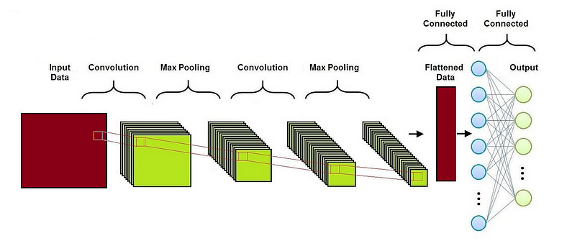
Obviously, the actual can vary widely based on the specific problem and dataset. The main difference between a classical CNN architecture and a GAN discriminator architecture are the following:
- Loss Function: CNNs use many different loss functions, while GAN’s Discriminator alwyas uses binary cross-entropy loss since it’s distinguishing between two classes (real vs. fake).
- Feedback Loop: While in CNN there’s no feedback loop with another network during its training and the CNN is trained in isolation using a labeled dataset, GAN’s Discriminator operates in tandem with the Generator. The Discriminator provides feedback to the Generator, allowing it to improve its image generation capabilities.
- Output Activation Function: Depending on the task, CNNs might use or not softmax activation, while GAN’s Discriminator typically uses a sigmoid activation function in the output layer to provide a probability score indicating whether the image is real or fake.
- Depth and Complexity: GAN’s Discriminator is often simpler and shallower than conventional CNNs, but of course the complexity depends on the specific GAN architecture and the dataset being used.
Training: During training, the discriminator updates its weights in the following way.
It is shown real data and should be trained to output values close to 1. It is shown fake data (generated by the generator) and should be trained to output values close to 0.
Challenges:
- Overpowering Discriminator: If the discriminator becomes too strong too quickly, it might always give a very confident output (either close to 0 or 1) for any input, making it hard for the generator to learn. This issue can be mitigated by implementing techniques like label smoothing, feature matching, or deliberately slowing down the training of the discriminator.
- Weak Discriminator: On the other hand, if the discriminator is too weak, the generator might not get meaningful feedback to improve. The balance between the generator and discriminator during training is crucial for the success of a GAN. This problem can be reduced by enhancing the capacity of the discriminator, carefully tuning its learning rate, or using advanced architectures that improve discriminative power.

GAN Loss
Generative Adversarial Networks (GANs) utilize loss functions to train both the generator and the discriminator. The loss function helps adjust the weights of these models during training to optimize their performance. Both the generator and the discriminator use the binary cross-entropy loss to train the models, that can be written as
where:
- L(y,p) is the loss value;
- y is the true label (either 0 or 1);
- p is the predicted probability of the sample belonging to class 1.

Discriminator Loss
The discriminator’s goal is to correctly classify real samples as real and fake samples (produced by the generator) as fake. Its loss is typically represented as:
where
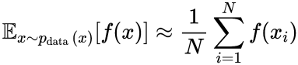
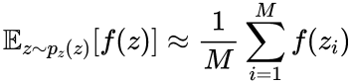
x_i​ are samples from the real dataset, N is the number of samples from the real dataset, z_i​ are samples from the noise distribution, and M is the number of samples from the noise distribution.
The first term on the right hand penalizes the discriminator for misclassifying real data, while the second term penalizes the discriminator for misclassifying the fake data produced by the generator.

Generator Loss
The generator’s goal is to produce samples that the discriminator incorrectly classifies as real. Its loss is typically represented as:
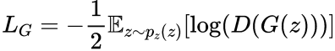
This term penalizes the generator when the discriminator correctly identifies its outputs as fake.

Combined Loss
The combined GAN Loss, often referred to as the minimax loss, is a combination of the discriminator and generator losses. It can be expressed as:
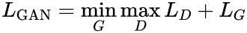
This represents the adversarial nature of GAN training, where the generator and the discriminator are in a two-player minimax game. The discriminator tries to maximize its ability to classify real and fake data correctly, while the generator tries to minimize the discriminator’s ability by generating realistic data.

Gradient Penalties
Gradient penalty is a technique used to stabilize the training by penalizing the gradients if they become too steep. This can help in stabilizing the training and avoiding issues like mode collapse.
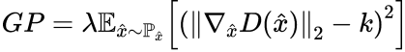
where
- GP represents the gradient penalty term;
- λ is a hyperparameter that controls the strength of the penalty;
- the gradient component is the gradient of the discriminator’s output with respect to its input x^;
- P_x^​ represents the distribution of interpolated samples between real and generated data;
- k is a target norm for the gradient, often set to 1;
The discriminator loss with gradient penalty can be incorporated as follows:
This loss function consists of the usual GAN discriminator loss components for real and generated data, plus the gradient penalty term to regularize the discriminator’s behavior. The key concept is that by penalizing large gradients, you encourage the discriminator to behave more smoothly, which can lead to a more stable training process for both the generator and the discriminator. This approach can be adjusted and adapted depending on the specific characteristics of the GAN architecture and the problem at hand.

